Important Information Regarding TSSA Additional Forms

The form editor within Easy Storage Solutions does not have a file import option; therefore, document formatting (spacing, bold, bullets, etc.) when copied into the system becomes inconsistent. Unfortunately, this is beyond our control. Easy Storage functionality may change as updates are made to the system.
We have provided the most popular forms in a TXT file to import into your Easy Storage account. The forms in their original format, along with all official TSSA forms, can still be found on the TSSA website (txssa.org). Importing the provided forms into your Easy Storage account is optional and for your convenience only.
The TXT file provides the content of the forms with all formatting removed. Once copied into Easy Storage it is highly recommended that you format the forms to appear as close to the original as possible. Changing the content/text of the forms will make them invalid – limit changes only to the aesthetics.
How to add the TSSA form to Easy Storage
- Login to your Easy Storage account
- From the top bar select Email, Txt & Print and then select Templates from the drop down options
- In the Custom Templates section click on ‘New Custom Template’ (located at the bottom of the page)
- Open the provided Text document file
- Select all the document text (Control or Command A)
- Copy the selected text (Control or Command C)
- Return to your Easy Storage account and paste the text in the Email/Letter Content box (Control or Command V)
- Adjust the fonts and sizing to appear as close to the original TSSA form as possible.
- Once complete, click on Create Template
You will need to complete these steps for each form you want to add.
How to add the TSSA member logo into your form
- Click here to download the TSSA member logo. Please note: You must log in to your account to download the member logo
- Save the TSSA logo to your desktop or another place where you can easily access it
- Login to your Easy Storage account and navigate to the template you wish to add the logo to
- Place your cursor where you want your logo to appear
- Click on the picture icon at the far right of the tool bar (see below)
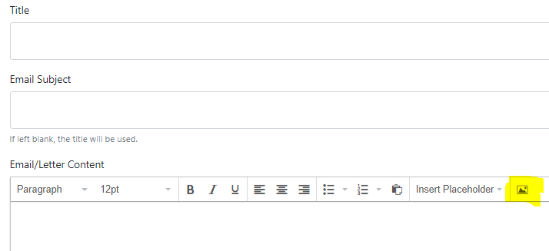

- Click on the Upload tab and then Browse for an image
- Find and select the saved TSSA member logo, click Open
- Click OK
Additional Information and Tips
- To edit a template, click on the template name.
- When pasting the form from the Word document font size and alignment may need to be adjusted.
- To print or email a form as is, without making any updates, select Email, Txt & Print and then Print/ Email Letters.
- If text needs to be updated or added to the form select Email, Txt & Print and then Send Email. Highlight the desired template from the dropdown under Select Template. Click on Choose to have the form pre-fill the body of the email and edit as needed.

